

***Dissertation on***

# “PAYCRYPTO: A Fintech Application for the Currency of Future”

*Submitted in partial fulfilment of the requirements for the award of degree of*

# Bachelor of Technology in

**Computer Science & Engineering UE20CS390A – Capstone Project Phase - 2**

***Submitted by:***

|  |  |
| --- | --- |
| **Harsh Agrawal Aryansh Garg Harshit Sharma**  **Sagarikha M** | **PES2UG20CS908 PES2UG20CS070 PES2UG20CS909**  **PES2UG20CS292** |

*Under the guidance of*

**Prof. Gauri S. Rapate** Assistant Professor PES University

**June - Nov 2023**

**DEPARTMENT OF COMPUTER SCIENCE AND ENGINEERING**

FACULTY OF ENGINEERING

**PES UNIVERSITY**

(Established under Karnataka Act No. 16 of 2013) Electronic City, Hosur Road, Bengaluru – 560 100, Karnataka, India

# PES UNIVERSITY

(Established under Karnataka Act No. 16 of 2013)

Electronic City, Hosur Road, Bengaluru – 560 100, Karnataka, India

**FACULTY OF ENGINEERING**

CERTIFICATE

*This is to certify that the dissertation entitled*

## ‘PAYCRYPTO: A Fintech Application for the Currency of Future’

*is a bonafide work carried out by*

|  |  |
| --- | --- |
| **Harsh Agrawal Aryansh Garg Harshit Sharma**  **Sagarikha M** | **PES2UG20CS908 PES2UG20CS070 PES2UG20CS909**  **PES2UG20CS292** |

In partial fulfilment for the completion of sixth semester Capstone Project Phase - 2 (UE20CS390A) in the Program of Study -Bachelor of Technology in Computer Science and Engineering under rules and regulations of PES University, Bengaluru during the period June 2023 – Nov 2023. It is certified that all corrections / suggestions indicated for internal assessment have been incorporated in the report. The dissertation has been approved as it satisfies the 7th semester academic requirements in respect of project work.

|  |  |  |
| --- | --- | --- |
| Signature  Prof. Gauri S. Rapate Assistant Professor | Signature Dr. Sandesh B J  Chairperson | Signature  Dr. B K Keshavan Dean of Faculty |

**External Viva**

|  |  |
| --- | --- |
| **Name of the Examiners**  **1.**  **2.** | **Signature with Date** |

# DECLARATION

We hereby declare that the Capstone Project Phase - 2 entitled **“PAYCRYPTO : A FINTECH APPLICATION FOR CURRENCY OF FUTURE”** has been carried out by us under the guidance of **Prof. Gauri S Rapate** , Assistant Professor and submitted in partial fulfilment of the course requirements for the award of degree of **Bachelor of Technology** in **Computer Science and Engineering** of **PES University, Bengaluru** during the academic semester June – Nov. 2023. The matter embodied in this report has not been submitted to any other university or institution for the award of any degree.

|  |  |
| --- | --- |
| **PES2UG20CS908** | **Harsh Agrawal** |
| **PES2UG20CS070** | **Aryansh Garg** |
| **PES2UG20CS909** | **Harshit Sharma** |
| **PES2UG20CS292** | **Sagarikha M** |

# ACKNOWLEDGEMENT

I would like to express my gratitude to **Prof. Gauri S Rapate** , Assistant Professor Department of Computer Science and Engineering, PES University, for her continuous guidance, assistance, and encouragement throughout the development of this UE20CS461A -Capstone Project Phase – 2.

I am grateful to the Capstone Project Coordinator, Dr. Sarasvathi V, Professor and Dr. Sudeepa Roy Dey, Associate Professor, for organizing, managing, and helping with the entire process.

I take this opportunity to thank Dr. Sandesh B J, Chairperson, Department of Computer Science and Engineering, PES University, for all the knowledge and support I have received from the department. I would like to thank Dr. B.K. Keshavan, Dean of Faculty, PES University for his help.

I am deeply grateful to Dr. M. R. Doreswamy, Chancellor, PES University, Prof. Jawahar Doreswamy, Pro Chancellor – PES University, Dr. Suryaprasad J, Vice-Chancellor, PES University for providing to me various opportunities and enlightenment every step of the way. Finally, this project could not have been completed without the continual support and encouragement I have received from my family and friends.

**ABSTRACT**

With the surge in popularity and acceptance of cryptocurrencies, there arises an increasing demand for reliable tools that can aid users in making well-informed choices regarding their cryptocurrency investments. In response, the proposed model introduce a comprehensive cryptocurrency application that integrates various essential features such as price prediction, wallet management, secure storage, peer-to-peer transactions, and investment strategy recommendations. The application's primary attribute is its cryptocurrency price prediction capability, leveraging advanced machine learning algorithms and historical market data to provide users with precise and up-to-date forecasts of cryptocurrency prices. These predictions serve as invaluable resources for investors, enabling them to anticipate market trends and make informed trading decisions. Moreover, the proposed application offers a secure and user-friendly wallet management system, facilitating the effortless creation and administration of cryptocurrency wallets, ensuring convenient storage and access to digital assets. Employing robust encryption algorithms and adhering to industry best practices, the wallets guarantee the utmost security for users' funds. Additionally, the application enables seamless peer-to-peer transactions, allowing users to securely send and receive cryptocurrencies directly within the platform, eliminating the need for intermediaries. This peer-to-peer transaction functionality ensures privacy, transparency, and efficiency in conducting cryptocurrency transfers.

# Table of Contents

|  |  |  |
| --- | --- | --- |
| **Chapter No.** | **Chapter Name** | **Page No.** |
| **I.** | **INTRODUCTION** | **8** |
| **I I.** | **PROBLEM STATEMENT** |  |
| **III.** | **LITERATURE REVIEW** |  |
| **IV.** | **SYSTEM REQUIREMENTS SPECIFICATION** |  |
| **V.** | **SYSTEM DESIGN** |  |
| **V I.** | **PROPOSED METHODOLOGY** |  |
| **V II.** | **IMPLEMENTATION AND PSEUDOCODE** |  |

|  |  |  |
| --- | --- | --- |
| **V III.** | **RESULTS AND DISCUSSION** |  |
| **IX.** | **CONCLUSION AND FUTURE WORK** |  |
| **X.** | **REFERENCES/BIBLIOGRAPHY** |  |

## LIST OF TABLES

|  |  |  |
| --- | --- | --- |
| **Table No.** | **Title** | **Page**  **No.** |
| **6.1** | **Table consisting of details with reference to entities and attributes** | **39 -**  **40** |

**LIST OF FIGURES**

|  |  |  |
| --- | --- | --- |
| **Figure No.** | **Title** | **Page No.** |
| **6.1** | **Data Flow Diagram** | **35** |
| **6.2** | **High Level Diagram** | **38** |
| **6.3** | **Master Class Diagram** | **41** |
| **6.4** | **ER Diagram** | **43** |
| **6.5** | **State Diagram** | **47** |
| **6.6** | **Use Case Diagram** | **49** |

|  |  |
| --- | --- |
|  | **I. INTRODUCTION**   * 1. **Purpose**   The purpose of the project is to make aware of the new digital currency which is in a hype these days and to make people gain knowledge of cryptocurrency and invest in these multiple currencies with the help of the PAYCRYPTO App which helps in using a machine learning model to forecast cryptocurrency values.   * 1. **Scope**      1. Conduct a comprehensive exploration and subsequent selection of sentiment analysis methodologies capable of effectively predicting cryptocurrency prices.      2. Collect and analyze data from a diverse array of sources, including social media platforms and blogs, to gain a nuanced understanding of public sentiment towards cryptocurrencies.      3. Using a machine learning model that leverages sentiment analysis to generate accurate cryptocurrency price predictions.      4. Seamlessly integrate the aforementioned machine learning model with an aesthetically-pleasing and user-friendly web application that provides users with access to predicted cryptocurrency prices.      5. Ensure the application is equipped with real-time data feeds that   reliably update the predicted cryptocurrency prices, thereby enhancing their accuracy. |

1. Provide users with access to historical cryptocurrency price data, thereby allowing them to make informed comparisons between the predicted and actual values.
2. Implement comprehensive user authentication protocols that safeguard sensitive user data and proactively prevent unauthorized access to the application.
3. Design and deploy an intuitive and visually-appealing user interface that enhances the user experience and enables easy navigation of the application's various features.
4. Continuously engage in extensive research and development initiatives to refine the cryptocurrency price prediction algorithms and enhance the application's overall functionality

## Motivation

* + - Fintech apps are increasingly relying on cutting-edge technologies like deep learning models to forecast future prices as a result of the unheard-of levels of market volatility caused by the quickly evolving world of cryptocurrencies. In order to create a comprehensive solution for forecasting cryptocurrency prices, the research leverages the capabilities of cutting-edge deep learning models, notably GRU (Gated Recurrent Unit) and LSTM (Long Short-Term Memory) models. The motivation comes from the

knowledge that deep learning models have unmatched forecasting powers, whereas conventional statistical models are sometimes insufficient for analysing the intricate and rapidly shifting cryptocurrency markets. Aim is to give users with very accurate and current predictions of cryptocurrency prices through the integration of these models into the fintech application, simplifying wise financial decision-making and generating value for all parties involved. The team is dedicated to expanding the potential of Cryptocurrency finance, and the project is an important addition to this area that is developing quickly.

|  |  |
| --- | --- |
| **II.** | **PROBLEM STATEMENT**   * The rapidly increasing popularity and buzz of this new technology based currency, called cryptocurrency, has sparked curiosity among the masses. Every other individual desires to experience this new currency to remain in the mainstream market. * People who understand the technology working behind it know the benefits of using this currency very well. * What if there was a platform that people can use to enter in this new world of cryptocurrency? * Surprisingly no such platform exists which is easy enough to be used by any individual whether he/she is well versed in technology or not. * PAYCRYPTO is such a platform which makes cryptocurrency easy to use. * What can be done with a currency(money)?   + It can be used for transaction   + It can be invested in different mechanisms to multiply it. * Since the beginning of time, it has been done with traditional currency but PAYCRYPTO makes it possible to do it with cryptocurrency as well. * It lets users make transactions to other users in the form of cryptocurrency. * Along with transactions, users can also invest in the cryptocurrency of their choice among the ones listed on the platform. * As cryptocurrency is a new deal in the market, it is very volatile in nature and makes it difficult for users to invest profitably but PAYCRYPTO has the solution for this problem too. The price prediction feature of it can give users the idea of the prices of the   currency beforehand and one can invest accordingly to be in the profit side at the end of the day. After all, that is what every user desires. |

|  |  |
| --- | --- |
|  |  |
| **III.** | **LITERATURE REVIEW**   * 1. **Multivariate Cryptocurrency Prediction: comparative analysis of three recurrent neural networks approaches**      1. **Introduction:**   The paper explores the use of recurrent neural networks (RNNs) for predicting cryptocurrency prices. They implement three RNN approaches (LSTM, GRU, and ESN) and compare their performance using data on various cryptocurrencies. The authors provide understanding into the potential of RNNs for cryptocurrency price prediction.   * + 1. **Characteristics and Implementation:**   This paper compares the performance of three different recurrent neural networks, LSTM, GRU, and ESN. They collected and pre-processed data on cryptocurrency prices and other relevant factors, and trained and evaluated the RNN models using Python and TensorFlow. Finally, different evaluation metrics are used to assess the performance of the models, and provide a conclusion on the strengths and weaknesses of the different  approaches. |

## Features:

The primary focus of this paper is predicting cryptocurrency prices using recurrent neural networks. They have taken up three different RNN approaches. The models are trained and evaluated using Python and TensorFlow to provide insights into the potential RNNs have for cryptocurrency price prediction.

## Evaluation:

The paper provides a valuable contribution to cryptocurrency research. The authors use various evaluation metrics to check the performance of the models and provide the strengths and weaknesses of each approach, which can be useful to researchers. One of the limitations can be seen, as it only focuses on predicting cryptocurrency prices and does not consider other aspects of the cryptocurrency market.

## Advantage:

Since three different RNNs are being used, the comparison can be an asset for researchers and practitioners interested in predicting cryptocurrency prices using RNNs. The methodology used- data collection and

preprocessing, training and evaluation of models using Python and TensorFlow. It provides a lot of insights into the potential of RNNs for prediction of cryptocurrency prices.

## Limitations:

This paper has a main focus- predicting cryptocurrency prices, but it does not consider other aspects of the cryptocurrency market. The number of cryptocurrencies included is limited as well, which limits the generalizability of the results.

## A Research On Bitcoin Price Prediction Using Machine Learning Algorithms

* + 1. **Introduction:**

The paper is based on predicting the price of Bitcoin using different machine learning algorithms. The price of bitcoin is rapidly changing. Hence, it is important to have accurate price prediction models. Data on bitcoin prices and economic indicators such as, currency exchange rates and stock market indices was analysed. After which machine learning algorithms like linear regression and artificial neural networks were implemented to develop price prediction models. This paper assesses the algorithms and provides the difference in each of their prediction accuracy and error rates. The authors also review what factors affect the efficiency

and accuracy of the models, for instance, the input variables and the size of the training data set.

## Characteristics and Implementation:

The authors analysed data on bitcoin prices and other economic indicators and estimated the performance of the different algorithms. They used multiple libraries with python to implement the machine learning algorithms. The performance was assessed using metrics including, MSE, RMSE and MAE, to find results so as to recognise the factors that affect the accuracy of the models.

## Features:

The focus of this paper is to provide predictions of bitcoin prices using machine learning algorithms, using collected data on bitcoin prices and other economic indicators to use in their models. It evaluates its performance using various metrics. Finally, the authors discuss the factors that impact the accuracy of the models, these can include, the training data size , and input variables.

## Evaluation:

The paper provides a debate on the factors that can affect the performance of the models, which is very useful for researchers who are interested in using machine learning algorithms. The results and conclusions provided by the authors are promising when taken with the study’s few limitations.

## Advantage:

It provides for a complete study on bitcoin price prediction using machine learning algorithms by evaluating the performance using various metrics, and it discourses the factors that affect the accuracy of the models which can help researchers for future studies.

## Limitations:

This study focuses on bitcoin, it doesn’t include other cryptocurrencies. There are many potential factors that could affect the bitcoin prices which are not included here.

## Cryptocurrency Price Prediction using Long Short-Term Memory and Twitter Sentiment Analysis

* + 1. **Introduction:**

The article explores the use of machine learning and sentiment analysis to forecast the direction of the cryptocurrency market, particularly for

Bitcoin. The authors use a deep neural network model called Long Short- Term Memory (LSTM) to analyze historical Bitcoin prices and Twitter data to predict future cryptocurrency prices. They also develop a dashboard prototype to assist investors in making investment decisions based on the predicted prices and the latest cryptocurrency updates. The paper highlights the value of integrating LSTM and sentiment analysis to forecast cryptocurrency prices accurately and provides a promising approach for future research in this field..

## Characteristics and Implementation:

* + - * The paper uses a deep neural network model called Long Short-Term Memory (LSTM) to predict the future price of Bitcoin based on historical prices and Twitter sentiment analysis.
      * The paper focuses on Bitcoin, considered a benchmark for most cryptocurrency trends.
      * The authors use the CRISP-DM methodology to manage the process of data preparation, building LSTM models and Twitter sentiment analysis, model evaluation, and deployment.
      * The paper provides a dashboard prototype for investors to make informed investment decisions based on the predicted prices and the latest cryptocurrency updates.
      * The study demonstrates the value of integrating LSTM and sentiment analysis to forecast cryptocurrency prices accurately, with positive

sentiment tweets predicting the price of Bitcoin three to four days in advance.

* + - * The authors used historical Bitcoin price data downloaded from Yahoo Finance and Twitter tweet data obtained from the Twitter API for the LSTM model and sentiment analysis.
      * The LSTM model used multiple neuron layers, including hidden LSTM layers, dropout layers, and a dense layer to predict Bitcoin's future price.
      * Sentiment analysis categorized Twitter sentiment as positive or negative to determine the relationship between sentiment and cryptocurrency price fluctuations.
      * The predicted Bitcoin price and Twitter sentiment data are integrated into a dashboard prototype to assist investors in making investment decisions.
      * The authors plan to expand their study by analyzing more Twitter data and developing more advanced models for predicting cryptocurrency prices.

## Features:

The article demonstrates the value of machine learning and Sentiment Analysis in predicting the direction of the cryptocurrency market, particularly Bitcoin. The LSTM model and Twitter Sentiment Analysis were used to predict future cryptocurrency prices and patterns with great

accuracy, and a dashboard prototype provided investors with relevant information and assisted in investment decision-making.

## Evaluation:

The authors describe the testing and validation of the system's performance, which showed promising results in accurately predicting the price of Bitcoin using Machine learning. The system also indicates that sentiment analysis of social media can improve the accuracy of predicting the price of Bitcoin.

## Advantage:

The use of LSTM and sentiment analysis provides a highly accurate method for predicting cryptocurrency prices, which can help investors make more informed decisions. The paper integrates historical price data with Twitter sentiment data to provide a more comprehensive understanding of cryptocurrency price fluctuations, which can help investors gain a better perspective on market trends.

## Limitations:

Limited Scope: The paper focuses only on Bitcoin and may not be applicable to other cryptocurrencies, which could limit its usefulness for investors who are interested in other digital currencies.

Lack of Long-Term Predictions: The paper focuses on short-term predictions (3-4 days in advance) and does not provide insights into long- term trends or fluctuations in the cryptocurrency market.

## Cryptocurrency Price Prediction Using LSTM and GRU Networks

* + 1. **Objective of the paper:**

This paper explores the effectiveness of LSTM and GRU models in predicting the daily closing values of cryptocurrencies. The authors analyzed the data of DOGEcoin, XRP, and OMG Network for almost two years, and the results showed that LSTM and GRU models could predict the daily closing values of these cryptocurrencies with reasonable accuracy. The paper also highlights the importance of predicting the evolution of cryptocurrencies and the role of Deep Learning techniques in this regard.

## Outcomes:

The paper's findings suggest that GRU algorithms may be more suitable for smaller datasets compared to LSTM, and the best performance was achieved using LSTM with 100 neurons in the hidden layer, 100 epochs, and a test base of 30% from the total database. The study provides valuable insights for investors and traders seeking to predict future prices of cryptocurrencies.

## Advantages:

* Ability to handle sequential data such as time series data.
* LSTM and GRU can capture long-term dependencies between data points.
* This model learns from previous predictions made allowing them to adapt and improve.

## Limitations:

These models may not be able to capture the impact of external factors such as news events and market sentiment, which have a huge effect on cryptocurrency prices.

## Predicting Price of Cryptocurrency - A Deep Learning Approach

* + 1. **Objective of the paper:**

This academic article's goal is to demonstrate and evaluate a cutting-edge method for using deep learning algorithms to forecast cryptocurrency values. Since cryptocurrencies are notorious for their extreme volatility and the shortcomings of conventional approaches to address the difficulties of predicting the future prices of cryptocurrencies.

## Advantages:

* It emphasises the benefits of utilising deep learning methods to estimate cryptocurrency values, including increased pattern detection, real-time flexibility, forecasting accuracy, and the possibility to forecast prices of other cryptocurrencies.

## Limitations:

* The paper does not cover Limited Generalizability in which it's possible that the deep learning models created for forecasting Bitcoin prices won't work for other cryptocurrencies. The price dynamics of each cryptocurrency may be unique, therefore the models created for Bitcoin may not be accurate for other cryptocurrencies.
* The paper does not cover Data accessibility in which in order to be trained and produce reliable predictions, deep learning models need a significant amount of previous data. Deep learning models for predicting cryptocurrency values may be difficult to create for newer coins because of the potential limited availability of such data.
* The paper does not provide a Potential for Overfitting. Deep learning models have a chance of becoming overly complicated and capturing noise in the data, which would produce poor generalisation results on new data. Overfitting is a problem that might make it difficult to create deep learning models for forecasting bitcoin prices.

## DL-GuesS: Deep Learning and Sentiment Analysis-Based Cryptocurrency Price Prediction[6]

* + 1. **Objective of paper:**

The paper proposed a machine learning model which is named as DL- GuesS to forecast the cryptocurrency prices using historical data and twitter sentiment analysis. The proposed model tries to bring in new features which have not been implemented yet to improve the accuracy of the prediction model.

## Advantages:

* The proposed model in the above paper takes into account the inter-dependencies of different cryptocurrencies for the price prediction.
* As the variation in prices of one currency can affect the prices of other currencies as well, this factor has been included as feature in the proposed model.

## Limitations:

* Including inter-dependencies of a lot of currencies may not be that beneficial as only the popular currencies have an effect on the prices of other currencies.
* Using a lot of features for predicting prices can lead to bad accuracy as a lot of features are there which do not have significant contribution in the prices.
* Only the features that are actually significant for the model must be identified and fed into the model to get better accuracy.

## Cryptocurrency Price Prediction with Convolutional Neural Network and Stacked Gated Recurrent Unit

**[7]**

## Objective of the paper:

The paper focuses on predicting the prices by using convolutional neural networks and stacked gated recurrent unit. The proposed hybrid model uses one-dimensional CNN and and stacked GRU which takes into account long range dependencies

## Advantages:

* + - * The proposed model which integrates convolutional neural network and stacked gated recurrent unit was being tested on three different

datasets of different cryptocurrencies and satisfactory results were observed.

* + - * Hyperparameter tuning was performed to calculate the optimal setting of the CNN and GRU model.
      * Root mean square error calculated for the proposed model gave satisfactory results.

## Limitations:

* + - * As cryptocurrency is new and volatile, analysing only the historical data is not sufficient for the effective prediction.
      * Opinions of influential personalities affect the prices of currencies greatly and the proposed model has not taken this factor into account.
      * Sentiment analysis of people towards cryptocurrencies on social media platforms when used as a feature in price prediction model can prove to be vital for achieving high accuracy which is not done in proposed model in this paper.

|  |  |
| --- | --- |
| **IV.** | **PROJECT REQUIREMENTS SPECIFICATION**  The software part of the application is explored in this section. This is very important with respect to the software development and in assessing whether the developmental goals have been met during the testing phase. The purpose of this section is to provide a detailed specification for the application that predicts cryptocurrency prices using machine learning and allows for wallet creation, buying and trading crypto, and peer-to-peer crypto transfers. This application is intended to provide users with an easy and secure way to invest in cryptocurrencies.  **4.1 Functional Requirements**   * **Crypto Price Prediction** - The application will provide users with the ability to predict the prices of different cryptocurrencies using machine learning. The machine learning model will be trained on historical cryptocurrency price data and will use this data to make predictions about future price movements. The application will allow users to select the cryptocurrencies they are interested in and will provide them with predictions of the future prices of those cryptocurrencies. * **Wallet Creation** - The application will allow users to create a wallet to store their cryptocurrencies. The wallet will be secure and will use industry-standard encryption techniques to protect users' private keys. Users will be able to create multiple wallets for different cryptocurrencies. * **Buying and Trading Crypto** - The application will allow users to buy and trade cryptocurrencies using their wallets. Users will be able to purchase cryptocurrencies using fiat currency or other cryptocurrencies.The application will also provide users with a trading platform where they can buy and sell cryptocurrencies based on the predicted prices. * **Peer-to-Peer Crypto Transfers** - The application will allow users to transfer cryptocurrencies to other users using QR codes or wallet details. The transfers will be secure and will use blockchain technology to ensure that the transactions are recorded on the blockchain.  Non-Functional Requirements **4.2.1 Performance Requirement:**   * + - * The application will be designed to handle a large number of users and transactions.       * The machine learning model will be optimized to provide accurate predictions in real-time.       * The application will also be designed to handle peak traffic and ensure that users have a seamless experience.  4.2.2Security and privacy Requirements:  * Access Control: The system should implement strict access control mechanisms to ensure that only authorized personnel can access user data. * The application will be designed with security in mind. * The wallet creation, buying and trading, and peer-to-peer transfer features will use industry-standard encryption techniques to protect users' private keys and ensure that all transactions are secure. * Anonymization: The system should use techniques like anonymization to protect user privacy, such as stripping identifying information from data before it is stored or transmitted.  4.2.3 Usability Requirements:  * + - * The application will be designed with a user-friendly interface that is easy to use and understand. The application will also provide users with educational resources to help them understand how to use the application and invest in cryptocurrencies.  4.2.3Hardware Requirements:  * Any PC with at least 4Gb ram and 256Gb storage with any modern web browser will be required to run the application. * A good internet connection .  4.2.4Software Requirements:  * Operating System : The project will require windows 7 or higher in windows PC or macOS Sierra 10.12.6 or higher.These OS with any modern web browser will be required to run the web application * Machine learning algorithms: The system will use machine learning algorithms to predict the prices of various crypto currencies using real time data . Hence machine learning algorithms and tools such as python   , tensorflow , keras and natural language toolkit will be required. |
|  |  |

|  |  |
| --- | --- |
| **V.** | **SYSTEM DESIGN**   * 1. **Design**   **5.1.1 Goals regarding design**:   * + - * The main aim regarding design of the application is to make it as user friendly as possible.       * To capture the mass customer base, the application needs to be smooth and easily understandable by any new user.       * The two basic activities a user can perform are investing in cryptocurrency and peer-to-peer transactions which are the highlight of the application.       * The design needs to be clean and minimal and should not be   cluttered with information that is not required. |

## 5.2 Architecture

The architecture can be defined by dividing the application into two parts:

* + - The cryptocurrency trading with price prediction
    - Peer to peer cryptocurrency transactions

## 5.2.1 hardware and software components

* + - 1. **Hardware components:**

The hardware components required can be a powerful CPU that can process and run the machine learning model for the price prediction component without any delay.

Along with CPU, high performance RAM is required in the system where the model will be running to make the process faster.

To store large amounts of data, storage devices with high read/write speeds are also required.

## Software components:

A machine learning model that can predict the prices of desired cryptocurrencies is required. The potential models can be Neural networks, Random forest, SVM, etc.

A software for peer-to-peer transactions is required that can carry out the transactions in a smooth manner without any hassle. Blockchain technologies are required as cryptocurrencies are based on blockchain technology which provides a secure network for transactions.

## System data flow

Data flow of the system can be divided into two parts:

* Historical data of the cryptocurrency from the dataset
* Sentiment analysis data from the tweets.

The historical price data will be preprocessed to extract features required for the prediction and the tweets will be preprocessed and classified into three categories namely positive, negative and neutral. The features from both the channels will then combine into neural network layer where the price prediction will be performed

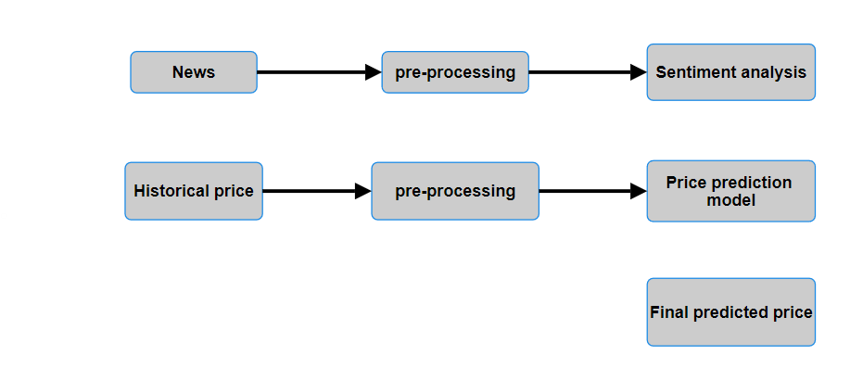

## Fig 5.1 : DATA FLOW DIAGRAM

Fig. 5.1 shows the overview of how the data is flowing through the model by going through various processes included in in

## System interfaces

The user interface of the application is required to be clean to make the whole user experience smooth and hassle free. As the goal of the application is to be user-friendly, having interfaces that are eye-catching while being minimal at the same time will help in achieving the goal

The different interfaces from which the user will interact with the application can be

1. Login page
2. Dashboard
3. Transaction page
4. Cryptocurrency price prediction

## Constraints

* Predicting the prices of cryptocurrencies accurately enough can be challenging.
* Building trust among customers towards the application is important so that people can use it without worrying about their money.
* Since the dataset of the cryptocurrencies is not very vast, prediction model has to be developed to give accurate results even with small datasets.
* Making the application absolutely secure is important to gain customer’s trust and to prevent ill-practices that can be done by some users.

## Assumptions

* Users have the devices with required specifications to run the application.
* Users have risk bearing capacity as cryptocurrency is quite volatile
* The prediction model can predict the prices with satisfactory accuracy.
* Users are from the location where using cryptocurrency is legal.

## Dependencies

* PAYCRYPTO is based on a machine learning model to predict the prices of currencies.
* The prediction model requires a historical dataset for training and testing.
* A different model for twitter sentiment analysis is needed along with twitter API to extract the tweets.
* It may depend on external APIs for example Google authentication.

## High Level Design

* + 1. **High Level Diagram**

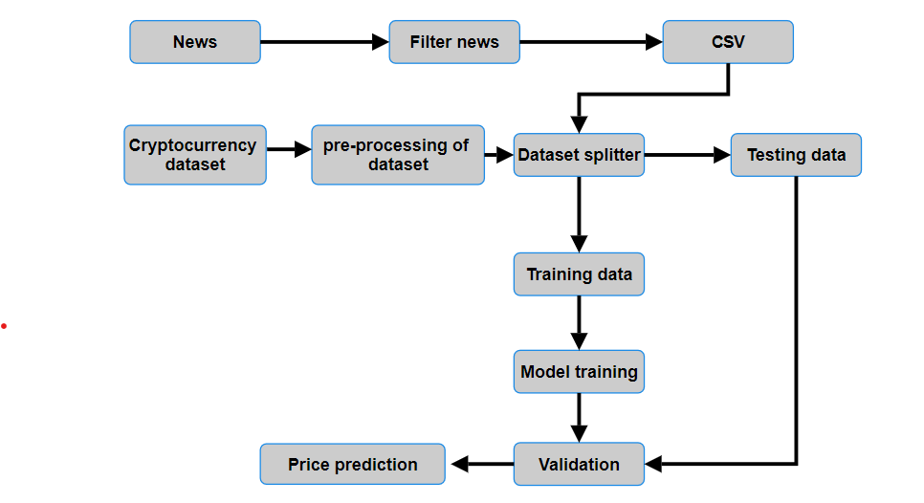

## Fig 5.2: High Level Diagram

The Fig 5.2 shows the functioning of PAYCRYPTO by showing the flow of the process that is being executed during the working of the application.

Broadly the workflow can be divided into two parts:

## News sentiment analysis

In this part, news headlines are being extracted and preprocessed to extract the features required for the prediction model. The headlines after the

preprocessing are being classified into three categories, positive, negative and neutral. The positive indicates that the headline is in favor of the cryptocurrency whereas negative indicates that it is against the cryptocurrency. Both positive and negative headlines will affect the prices of cryptocurrencies. the first will contribute in making the price high and the later will contribute in depreciating the price. The neutral headline will indicate that no opinion has been communicated regarding the cryptocurrency prices.

## Historical data analysis

The second part deals with historical price data of the cryptocurrencies. The dataset will be preprocessed to extract relevant features required for the price prediction model. After feature extraction from historical data, features from both the parts will be introduced to the prediction model where the future prices of the cryptocurrency will be calculated.

The user will be able to make an account as the first step in using the application. After logging-in into the account the user will have options to either make the transactions, or can check the predicted prices for the cryptocurrencies and can make the informed decision of whether to invest in it or not.

## Modules

* Data collection and cleaning module: It involves collecting historical dataset and preprocessing it to extract the relevant features required for the price prediction model.
* Feature extraction: After collecting the data, relevant features will be extracted by preprocessing the dataset that will be the input for the price prediction model.
* Price prediction model: It involves developing a machine learning model that can take features from historical data as well as twitter sentiment analysis to predict the future prices of cryptocurrencies.
* Portfolio management: It involves building a portfolio page where users can track their profit and loss and can check wallet balance.

## Design Descriptions

* + 1. **Master Class Diagram**

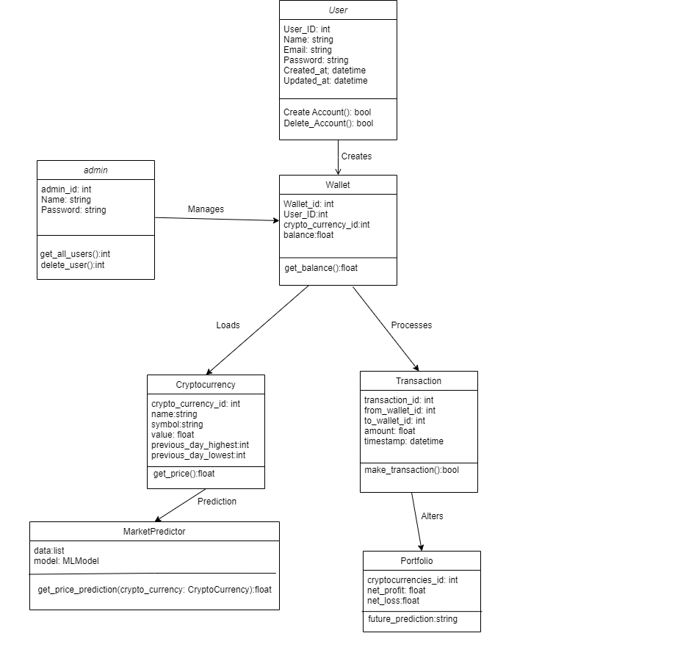

## Fig 5.3: Master Class Diagram

Fig 5.3 is the class diagram of the FinTech Application. The Class Diagram consists of 6 objects and their respective functions and services they

provide. This help in the understanding of the project blueprint and how it will be implemented.

|  |
| --- |
| **5.4 ER Diagram** |
| **Fig 5.4: ER Diagram** |

|  |  |  |  |  |
| --- | --- | --- | --- | --- |
| **#** | **Entity** | **Name** | **Definition** | **Type** |
| **ENTITIES** | | | | |
| 1 | Entity | User | Contains information of the user. | Strong |
| 2 | Entity | Login | Stores data regarding login details. | Weak |
| 3 | Entity | Wallet | Contains details of money stored in it. | Strong |
| 4 | Entity | Transaction | Has data for every transaction details | Strong |
| 5 | Entity | Portfolio | Stores data of cryptocurrencies users are holding | Strong |
| 6 | Entity | Currency | Stores details of different cryptocurrencies | Strong |
| **#** | **Attribut e** | **Name** | **Definition** | **Type (size)** |
| **DATA ELEMENTS** | | | | |
| 1 | Attribut e | User_ID | Id of the user | Int |
| 2 | Attribut e | Password | Password of the user | Varchar( 30) |
| 3 | Attribut e | Email | Email of the user | Varchar( 20) |

|  |  |  |  |  |
| --- | --- | --- | --- | --- |
| 4 | Attribut e | Name | Name of the user | Varchar( 30) |
| 5 | Attribut e | Age | Age of the user | Int |
| 6 | Attribut e | Location | Location of the user | Varchar( 20) |
| 7 | Attribut e | Currency | Cryptocurrency Type | Int |
| 8 | Attribut e | WalletID | Details of Wallet | Int |
| 9 | Attribut e | Amount | Balance in Wallet | Float |
| 10 | Attribut e | Date & Time | Date & Time of Transaction | DATETIM E |
| 11 | Attribut e | TransId | Details of Transaction | Int |
| 12 | Attribut e | SenderId | Details of Sender | Int |
| 13 | Attribut e | ReceiverId | Details of Receiver | Int |
| 14 | Attribut e | ProfitAmt | Net profit | Float |
| 15 | Attribut e | LossAmt | Net Loss | Float |
| 16 | Attribut e | CurrencyOw ned | CurrencyId of currency type | Int |
| 17 | Attribut e | CurrencyId | Details of Currency | Int |
| 18 | Attribut e | CurrencyVal ue | Value of Currency | Float |

|  |  |  |  |  |
| --- | --- | --- | --- | --- |
| 19 | Attribut e | Predicted Value | Approximated predicted value of currency | Float |
| 20 | Attribut e | Previous Day Highest | Highest value of currency for Previous Day | Float |
| 21 | Attribut e | Previous Day Lowest | Lowest value of currency for Previous Day | Float |

## Table 5.1: Table consisting of details with reference to entities and attributes

* 1. **State Diagram**

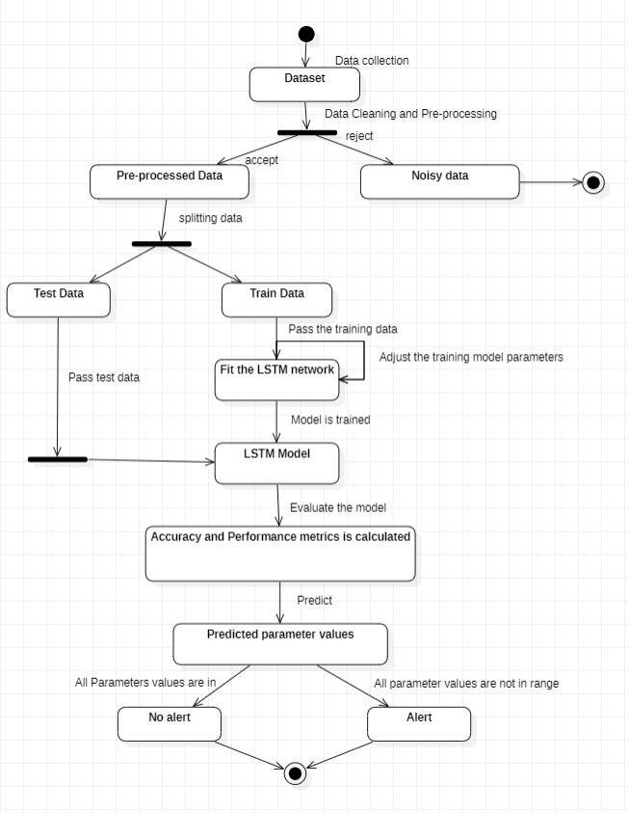

## Fig 5.5 : State diagram of machine learning model

* + - The dataset collected will be first cleaned and noise will be removed.
    - After that the data will be preprocessed and divided into two parts, testing data and training data.
    - The training data will be passed through the model to get the results from the model
    - Now test data will be passed and accuracy of the results will be evaluated.
    - If the desired accuracy standards are met then the model will said to be ready otherwise further changes will be made to make the model perform better.

## 5.7Use Case Diagram

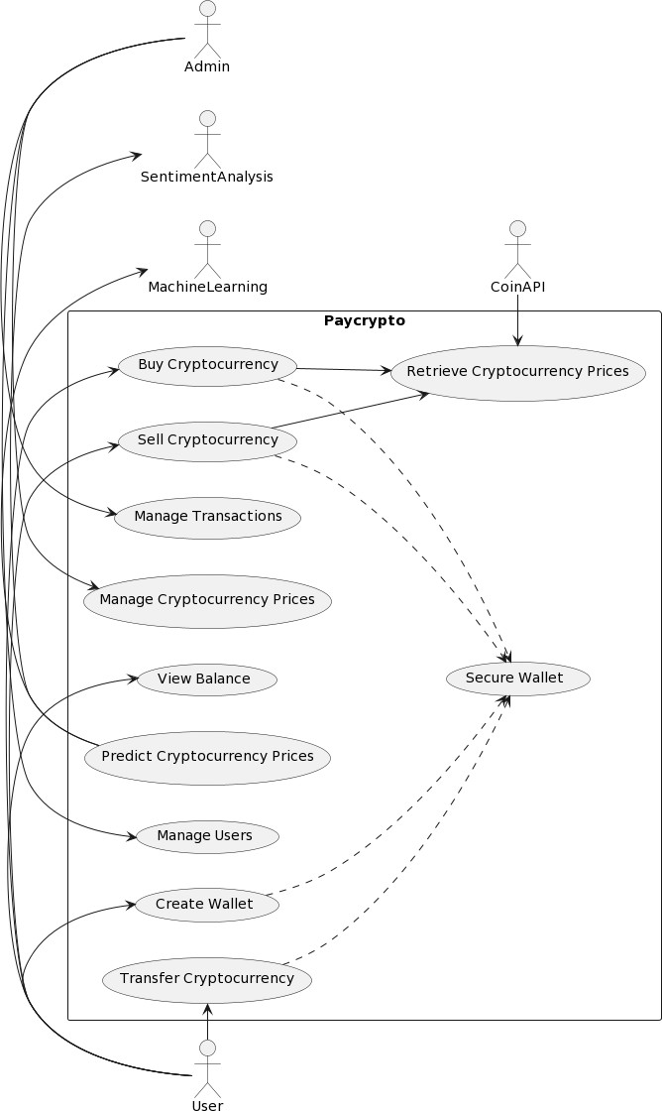

**Fig 5.6: Use Case Diagram**

|  |
| --- |
| * The use case diagram has five main actors in the system: user, admin, machine learning model, sentiment analysis and coinAPI. The user will be able to perform multiple use cases, including, create wallet to create a new cryptocurrency wallet to store their funds, buy and sell cryptocurrencies, transfer cryptocurrency to another wallet, and view balance. * The admin will be able to manage the registered users of the system, manage their transactions and manage cryptocurrency prices as well. There is machine learning actor along with the sentiment analysis actor that uses historical data and sentiments of tweets respectively to give us the final cryptocurrency price prediction. * The coinAPI actor performs retrieve cryptocurrency prices use case, which allows the system to retrieve real-time data and historical data on cryptocurrency prices. * The secure wallet class is used by several use cases. Since there is a lot of sensitive information and financial transactions, security is a critical aspect of this application. The proposed model will make sure of this security while the user buys cryptocurrencies, sells cryptocurrencies, creates a wallet or transfers cryptocurrencies through the secure wallet use case. |
| **VI. PROPOSED METHODOLOGY**   * **Basic approach :** * **The project is divided basically into two major parts** * The cryptocurrency trading with price prediction * Peer to peer cryptocurrency transactions   For the first part, a machine learning model will be developed with historical data and social media sentiment analysis to predict the prices of different currencies.  Sentiment analysis is being used along with historical data to bring in the fact that many influential personalities can affect the prices through their opinions and views towards the crypto market on social media. Constraints  * The app's performance will be limited by the speed and accuracy of external APIs used to gather market data. * The app's performance may also be constrained by the user's hardware and network capabilities. * The app will need to adhere to security and privacy regulations regarding user data storage and transmission. * The app will need to adhere to regulations regarding the use of predictive analysis algorithms for financial purposes.  Assumptions  * Users will have access to the internet and a compatible device to use the app. * The app will be deployed on a cloud-based infrastructure. * Users will have some basic understanding of cryptocurrency and its market trends. * The app's predictive analysis algorithm will be accurate in predicting cryptocurrency prices.  Dependencies  * The app will depend on external APIs to access data related to cryptocurrency market trends. * The app will depend on user input to refine the sentimental analysis algorithm.   **6.1 ALGORITHMS :**   * **LSTM :** Long Short-Term Memory (LSTM) networks are a modified version of recurrent neural networks, which makes it easier to remember past data in memory. The vanishing gradient problem of RNN is resolved here. LSTM is well-suited to classify, process and predict time series given time lags of unknown duration. It trains the model by using back-propagation. In an LSTM network, three gates are present: |

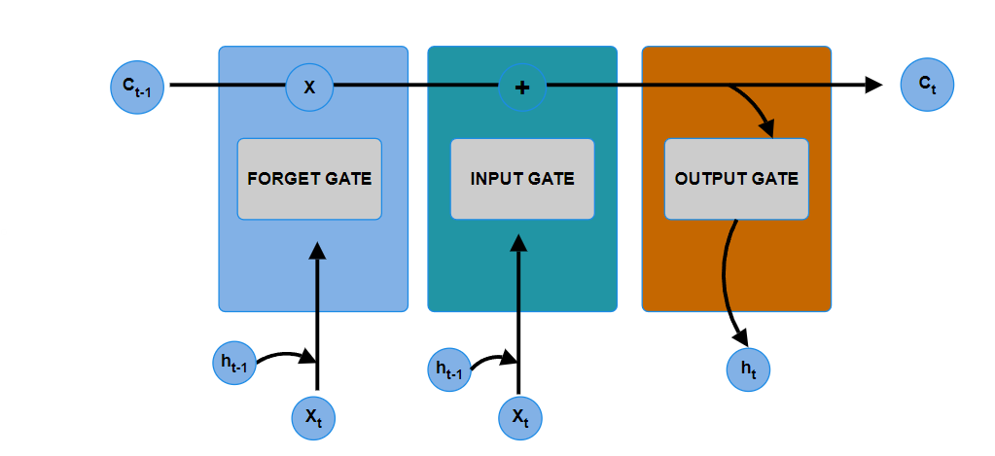

Fig 6.1 LSTM GATES

|  |
| --- |
| * **Input gate —** discover which value from input should be used to modify the memory. Sigmoid function decides which values to let through 0,1. and tanh function gives weightage to the values which are passed deciding their level of importance ranging from-1 to 1.      * **Forget gate —** discover what details to be discarded from the block. It is decided by the sigmoid function. it looks at the previous state(ht-1) and the content input(Xt) and outputs a number between 0(omit this)and 1(keep this)for each number in the cell state Ct−1.      * **Output gate —** the input and the memory of the block is used to decide the output. Sigmoid function decides which values to let through 0,1. and tanh function gives weightage to the values which are passed deciding their level of importance ranging from-1 to 1 and multiplied with output of Sigmoid.     **VII. IMPLEMENTATION AND PSEUDOCODE**  **7.1 Data Representation:** The used dataset is history of Ethereum prices per day from January, 2018 That is to say, there are 2141 data samples. Each of them has the associated timestamp and Ethereum price information. The dataset contains five columns for the prices namely “Open”, “Close”, “High”, “Low”, “Adj Close”. For price prediction all the five prices have been considered as features for the model.      **Fig 7.1 dataset representation**  **7.2 Data Pre-processing :**The news headlines related to Ethereum received are pre-processed for the sentient analysis. First of all, stop words, special characters and symbols have been removed and then stemming have been performed for the sentiment analysis. The sentiment analysis gives the score between -1 to 1 where the lesser the score the negative the sentiment.    7.3 Data Split  As previously mentioned, the data is composed of 1293167 instances. The decision  of how to split the data was taken trying to both have a large percentage of the  data to learn (the more data, the more a model can opt to learn) and to keep a  reasonably long and heterogeneous sample as the test one. Therefore, the model  was trained with the first 120000 instances (92.2% of the data), while the  remaining 9316 (7.8%) were used as a test. They correspond to a period of time,  during the first half of 2020, with large, fast changes in the value of the Bitcoin,  which make the prediction task really challenging.  **7.3 Data Split :** As previously mentioned, the data is composed of 2141 instances. The decision of how to split the data was taken trying to both have a large percentage of the data to learn (the more data, the more a model can opt to learn) and to keep a reasonably long and heterogeneous sample as the test one. Therefore, the model was trained with the first 80% instances, while the remaining 20% were used as a test.    **7.4 Model Code:**  Below is the multivariate LSTM machine learning model code which has been implemented. The model uses five features for the prediction and since it is multivariate the model can predict only one day in the future. |
|  |

## REFERENCES/BIBLIOGRAPHY:

1. Andrei-Alexandru Ecean , Daniel Zinca : “Cryptocurrency Price Prediction using LSTM and GRU Networks” , 2022 International Symposium on Electronic and Telecommunications
2. Muhammad Hussaini Bin Mohd Sabri , Amgad Muneer , Shakriah Mohd Taib

: “Crytocurrency Price Prediction Using LSTM and Twitter Sentiment Analysis”,2022 6th International Conference on Computing , Communication , Control and Automation

1. Joanne Gomes, Delisa Correia,Samiksha Marne,Shweta Churi : Predicting Price of Cryptocurrency - A Deep Learning Approach” NTASU - 2020 Conference Proceedings, International Journal of Engineering Research & Technology (IJERT).
2. R. Parekh et al., "DL-GuesS: Deep Learning and Sentiment Analysis-Based Cryptocurrency Price Prediction," in IEEE Access, vol. 10, pp. 35398-35409, 2022, doi: 10.1109/ACCESS.2022.3163305.
3. Kang, Chuen Yik, Chin Poo Lee, and Kian Ming Lim. "Cryptocurrency Price Prediction with Convolutional Neural Network and Stacked Gated Recurrent Unit." *Data* 7, no. 11 (2022): 149.
4. Lekkala Sreekanth Reddy, Dr.P. Sriramya : “A Research On Bitcoin Price Prediction Using Machine Learning Algorithms” - INTERNATIONAL JOURNAL OF SCIENTIFIC & TECHNOLOGY RESEARCH VOLUME 9, ISSUE 04, APRIL 2020.
5. Seng hansun, Arya Wicaksana, Abdul Q.M. Khaliq : “Multivariate cryptocurrency prediction: comparative analysis of three recurrent neural networks approaches” – in Journal of Big Data, Article no. 50, April 2022.